Lesson 11 Full Study Guide with Flowcharts

Study Guide Content
This section includes all objectives, explanations, vocabulary, deep dives, summaries, code snippets, video links, and references from Lesson 11.

Visual Flowcharts for Key Concepts

useEffect Lifecycle Flowchart
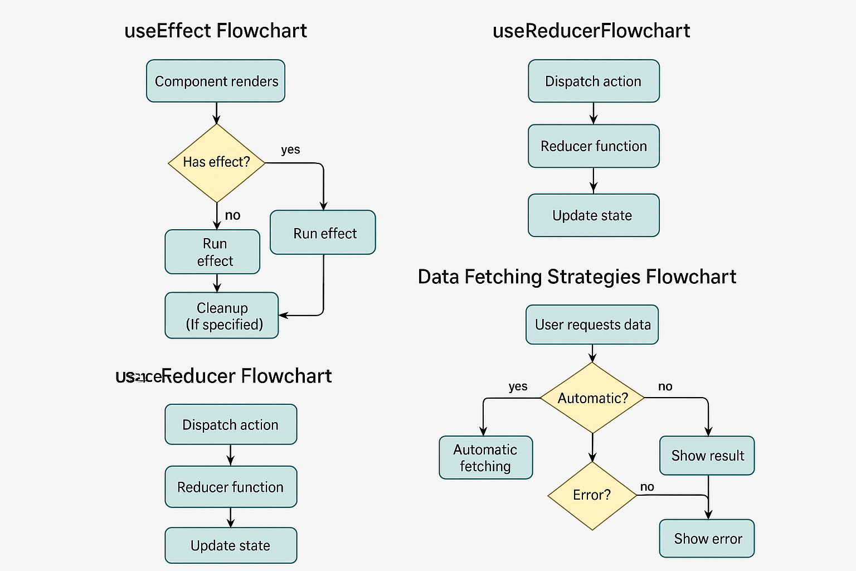

useReducer State Management Flowchart
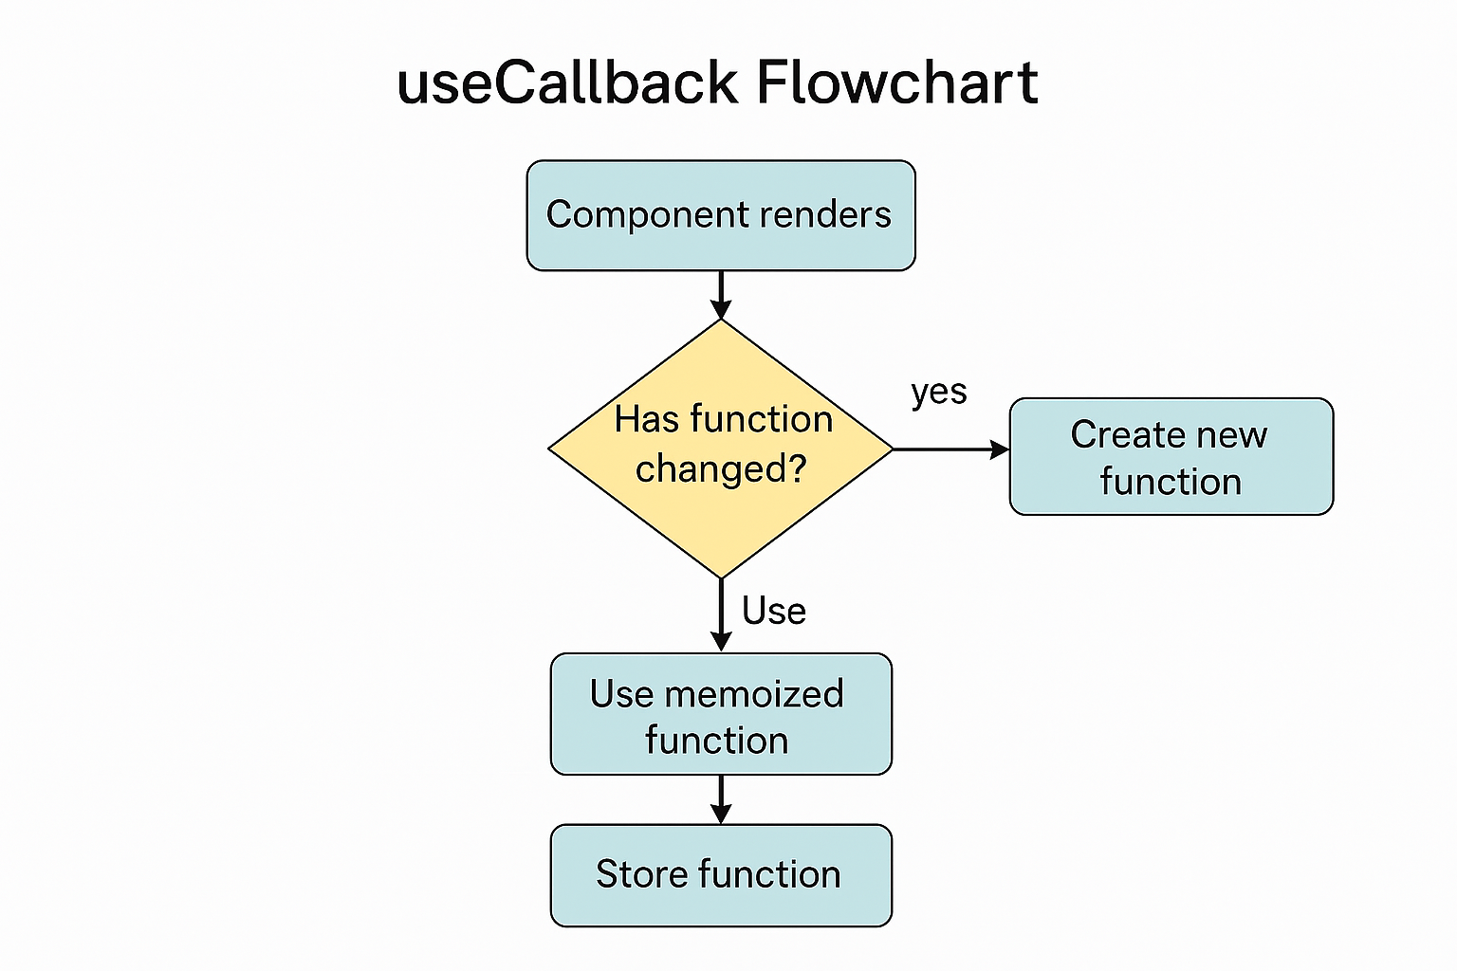

Data Fetching Strategies Flowchart

useCallback Optimization Flowchart

